**Multiusers Painting Web Application – Group Paint Online**

**Team Members:**

Fadi Farah & Aya Habashi

**User Stories:**

Could have:

As a user I would like to have a detailed starting homepage description so that I can understand what the web site is about.

Must have:

As a user I want to register/login so I can access the web site using my saved preferences.

Could have:

As a user I would like to automatically login upon return so that I can speed up my entry.

Could have:

As a user I would like to be able to make my own painting room with room privacy option(public/public) to avoid random people joining/disturbing.

Must have:

As a user I want to be able to view the list of all available rooms so I can choose which to join.

Must have:

As a user, I want to have a real-time updatable rooms' list so that if a room was added/removed, I don't have to refresh the page in-order to see it.

Must have:

As a user, I want to have a multi-user functionality inside the room so that more than one user in the same room can work on the same painting.

Could have:

As a user I would like to have a room chat so that I can be able to communicate and discuss certain subjects with other users in the same room.

Could have:

As a user, I would like to see a list of the users' names inside the room so that I'm able to know who I'm interacting/working with.

Must have:

As a user I want to have an eraser tool so that I can erase the unnecessary painting/drawing.

Must have:

As a user I want to have a color options tool to change my paint color.

Must have:

As a user I want to have a brush size slider so that I can change the size of my brush.

Must have:

As a user I want to have a undo/redo buttons so that I can change the current image state of my drawing back and forth.

Must have:

As a user I want to have a clear button so that I can clear all the current paint work inside my canvas.

Must have:

As a user I want to be able to download my paint work so that I can have it on my own device.

Must have:

As a user I want to be able to save my paint work on the website so that I can edit/update it later.

Must have:

As a user I want to be able to delete my paint work from the website so that I don't see unnecessary/unneeded paintings.

Must have:

As a user I want to have a list of all my saved paint works so I can view them anytime I need.

**User Interface:**

**Login Page:**



**Register Page:**



**Not authorized Home/Landing Page:**



**Authorized Home/Landing Page:**

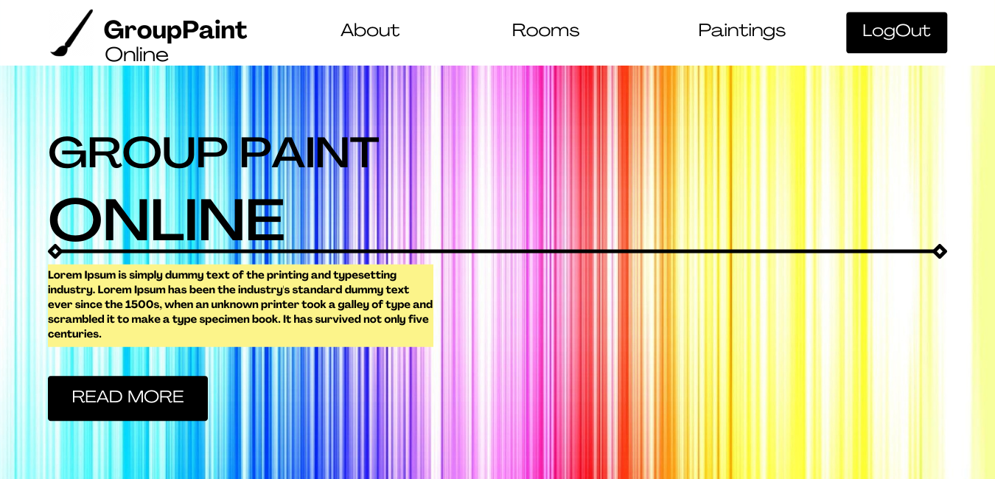

**Available Rooms List Page:**

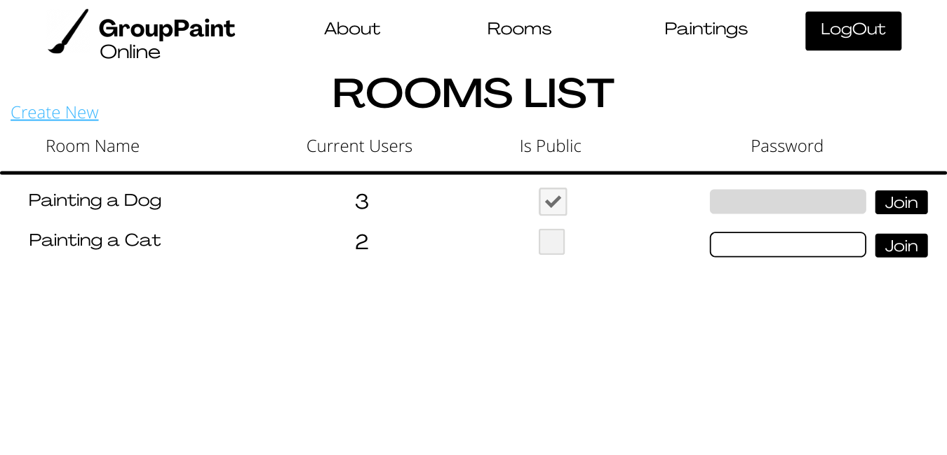

**Create a Room Page:**

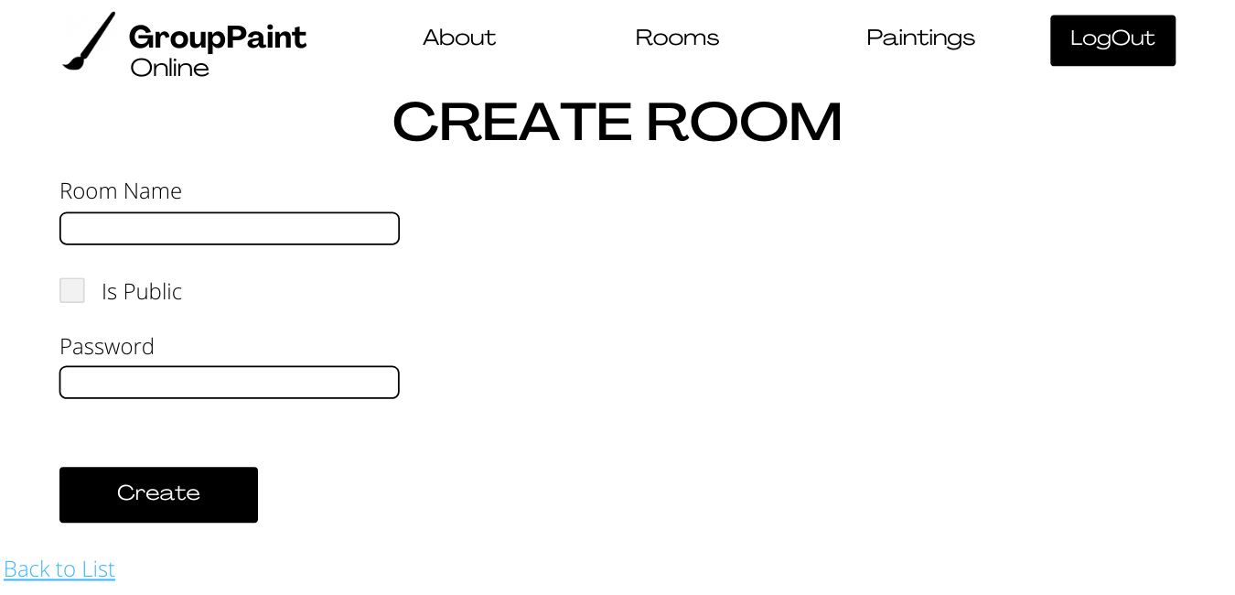

**Painting Room Page:**

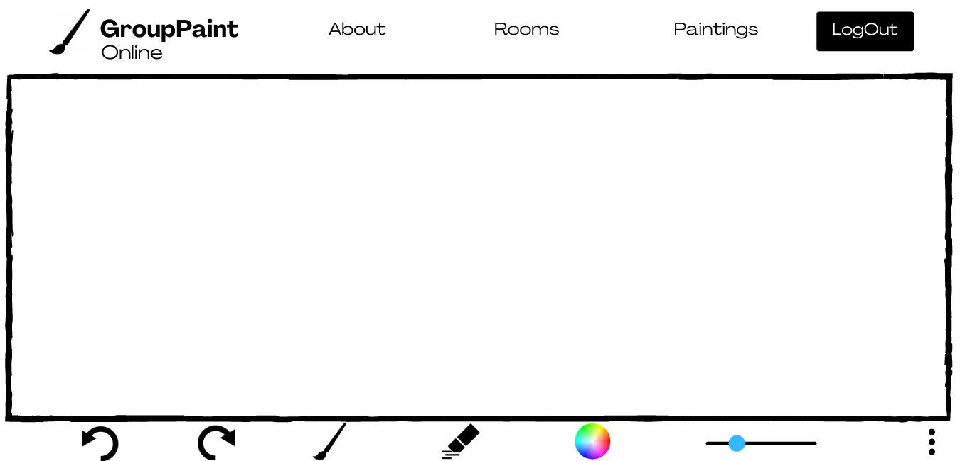

**Painting Works List Page:**

